Flex

1.Display 2.Direction 3.Wrap 4.Flex-flow 5.Justify-content 6.align-content

<html>

<head>

<style>

.flex-container {

  display: flex;

  flex-direction: column;

  background-color: DodgerBlue;

}

.flex-container > div {

  background-color: #f1f1f1;

  width: 100px;

  margin: 10px;

  text-align: center;

  line-height: 75px;

  font-size: 30px;

}

</style>

</head>

<body>

<h1>The flex-direction Property</h1>

<p>The "flex-direction: column;" stacks the flex items vertically (from top to bottom):</p>

<div class="flex-container">

  <div>1</div>

  <div>2</div>

  <div>3</div>

</div>

</body>

</html>

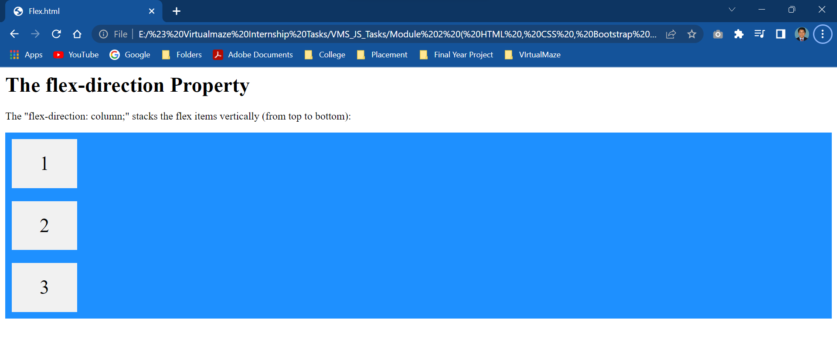

<html>

<head>

<style>

#main {

  width: 200px;

  height: 200px;

  border: 1px solid #c3c3c3;

  display: flex;

  flex-wrap: wrap;

}

#main div {

  width: 50px;

  height: 50px;

}

</style>

</head>

<body>

<h1>The flex-wrap Property</h1>

<div id="main">

  <div style="background-color:coral;">A</div>

  <div style="background-color:lightblue;">B</div>

  <div style="background-color:khaki;">C</div>

  <div style="background-color:pink;">D</div>

  <div style="background-color:lightgrey;">E</div>

  <div style="background-color:lightgreen;">F</div>

</div>

<p><b>Note:</b> Internet Explorer 10 and earlier versions do not support the flex-wrap property.</p>

</body>

</html>

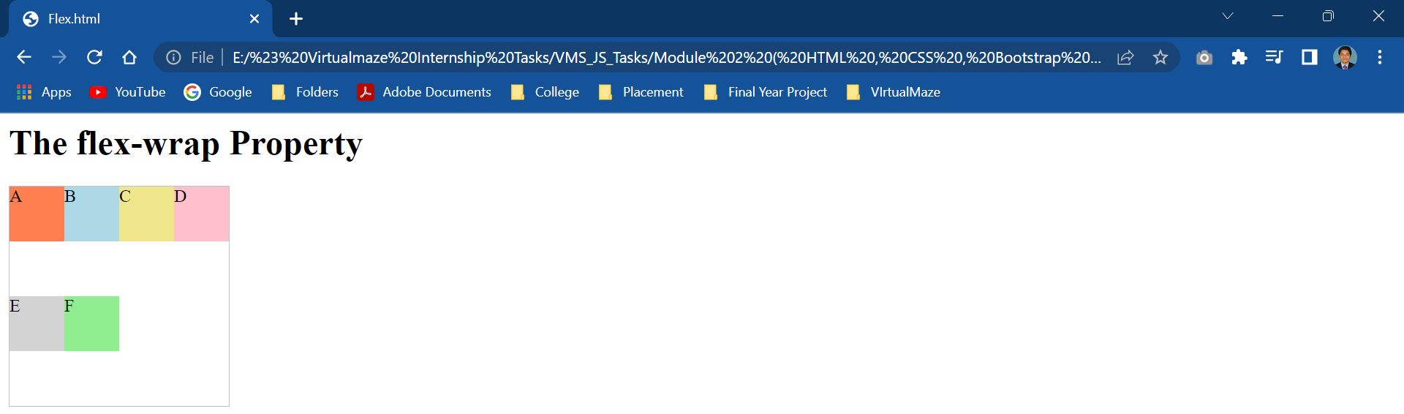

<html>

<head>

<style>

#main {

  width: 200px;

  height: 200px;

  border: 1px solid #c3c3c3;

  display: flex;

  flex-flow: row-reverse wrap;

}

#main div {

  width: 50px;

  height: 50px;

}

</style>

</head>

<body>

<h1>The flex-flow Property</h1>

<div id="main">

  <div style="background-color:coral;">A</div>

  <div style="background-color:lightblue;">B</div>

  <div style="background-color:khaki;">C</div>

  <div style="background-color:pink;">D</div>

  <div style="background-color:lightgrey;">E</div>

  <div style="background-color:lightgreen;">F</div>

</div>

</body>

</html>

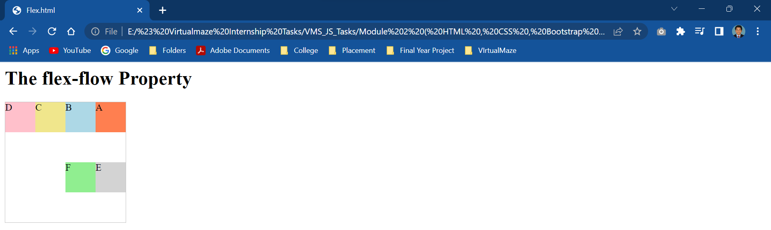

<html>

<head>

<style>

#main {

  width: 400px;

  height: 100px;

  border: 1px solid #c3c3c3;

  display: flex;

  justify-content: center;

}

#main div {

  width: 70px;

  height: 70px;

}

</style>

</head>

<body>

<h1>The justify-content Property</h1>

<p>The "justify-content: center;" aligns the flex items at the center of the container:</p>

<div id="main">

  <div style="background-color:coral;">1</div>

  <div style="background-color:lightblue;">2</div>

  <div style="background-color:pink;">3</div>

</div>

</body>

</html>

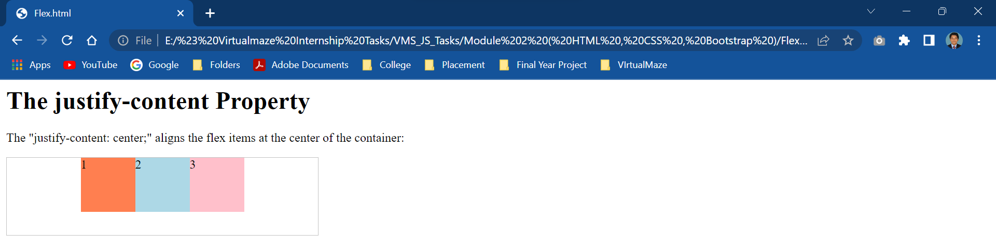

<html>

<head>

<style>

#main {

  width: 70px;

  height: 300px;

  border: 1px solid #c3c3c3;

  display: flex;

  flex-wrap: wrap;

  align-content: center;

}

#main div {

  width: 70px;

  height: 70px;

}

</style>

</head>

<body>

<h1>The align-content Property</h1>

<div id="main">

  <div style="background-color:coral;"></div>

  <div style="background-color:lightblue;"></div>

  <div style="background-color:pink;"></div>

</div>

</body>

</html>

